19ECE383-VLSI DESIGN LAB
PROJECT TITLE- UART SERIAL COMMUNICATION
GROUP MEMBERS- PUJIITA SRIEYA BOLISETTY - CB.EN.U4ECE21243
PUPPALA SRAVAN
- CB.EN.U4ECE21244
SVS KARTHIK
- CB.EN.U4ECE21256

OBJECTIVE:
  - Implement UART serial communication between two UART modules.
  - Establish bidirectional communication between two UART modules to facilitate data exchange.
  - Validate the UART communication protocol's functionality through simulation and testing.
  - Demonstrate the hardware implementation of UART communication on an FPGA board.

BLOCK DIAGRAM WITH DESCRIPTION:
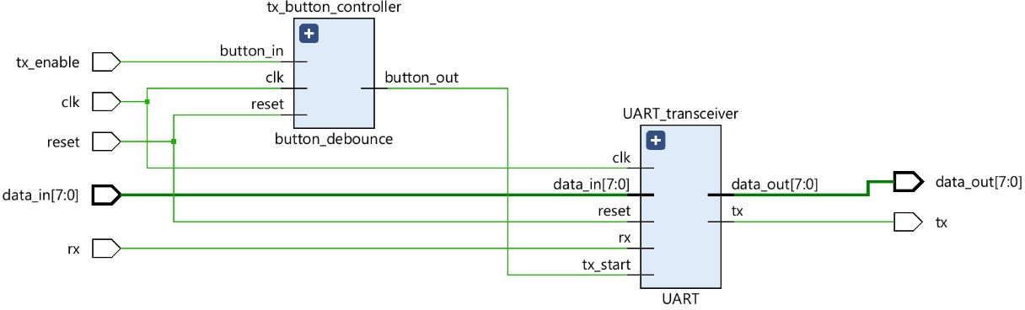

This project aims to design a bidirectional data transmission interface enabling communication between a physical board and a computer terminal. The system facilitates the transmission of data from the board to the terminal by activating a push button on the board, while data can be sent from the terminal to the board as well. The user switches on the board are utilized to set the data to be transmitted, and the received bits are visualized through user LEDs.

C) MODULES OF THE SYSTEM AND STATUS AS ON 30/03/2024:

MODULE-1 | UART-DESIGN
MODULE-2 | CREATING UART TRANSMITTER AND RECEIVER
MODULE-3 | BUTTON DEBOUNCE AND CONTROLLER
MODULE-4 | TESTBENCH CODE AND LOADING xdc,wfcg FILES
MODULE-5 | HARDWARE IMPLEMENTATION USING BASYS-3 BOARD

STATUS OF THE WORK: SIMULATION COMPLETED

d) CODE FOR MODULES WITH COMMENTS: MODULE-1: UART DESIGN:
library IEEE;

use IEEE.STD_LOGIC_1164.ALL; use IEEE.NUMERIC_STD.ALL;

entity UART is

port(
clk | : in std_logic; | -- Clock input
reset | : in std_logic; | -- Reset input
tx_start | : in std_logic; | --Transmission
start signal input

data_in : in std_logic_vector (7 downt0 0); -- Data input
data_out : out std_logic_vector (7 downto 0); -- Data output
rx : in std_logic; -- Receive input tx : out std_logic -- Transmit output
);

end UART;

architecture Behavioral of UART is component UART_tx
port(

clk : in std_logic; -- Clock input reset : in std_logic; -- Reset input tx_start : in std_logic; --
Transmission start signal input

tx_data_in : in std_logic_vector (7 downto 0); -- Data input

tx_data_out : out std_logic -- Transmit output
);

end component; component UART_rx
port(
clk | : in std_logic; | -- Clock input
reset | : in std_logic; | -- Reset input

rx_data_in : in std_logic; -- Receive input
rx_data_out : out std_logic_vector (7 downto 0) -- Data output
);

end component; begin
transmitter: UART_tx port map(
clk => ck,

reset => reset, tx_start => tx_start, tx_data_in => data_in, tx_data_out => tx
);

receiver: UART_rx port map(
clk => clk,

reset => reset, rx_data_in => rx, rx_data_out => data_out
);

end Behavioral;

MODULE-2: UART TX AND RX:

TRANSMITTER CODE:
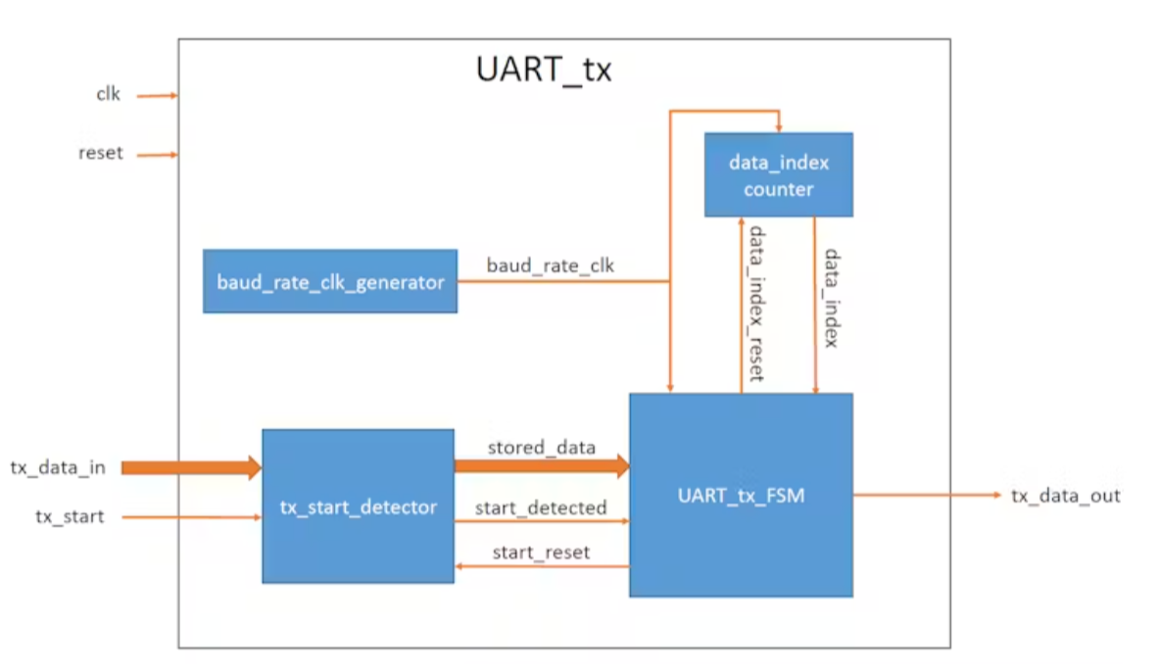

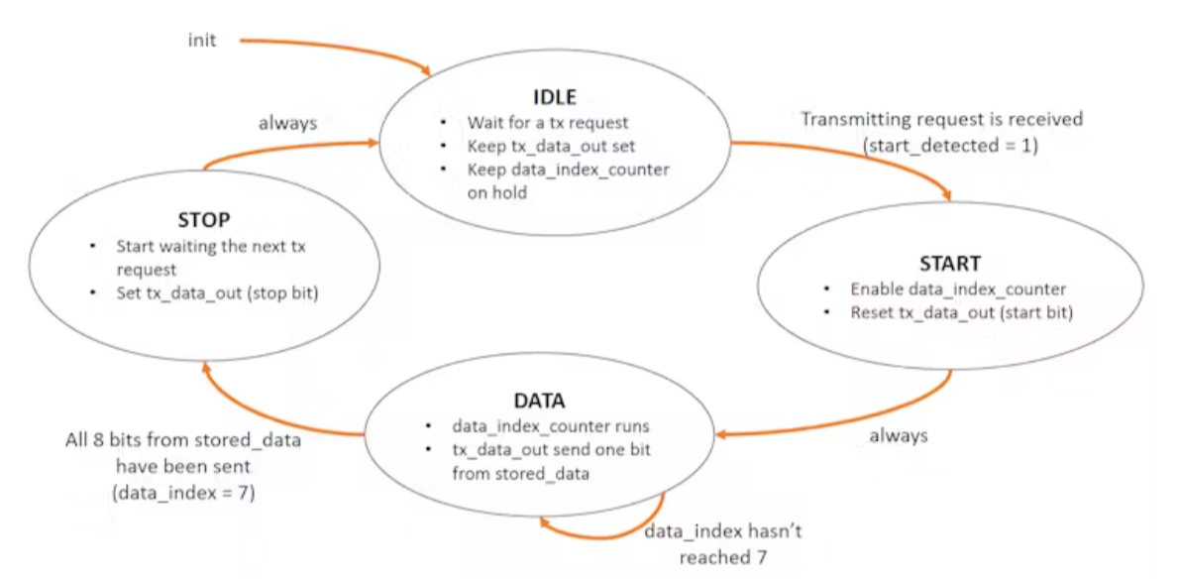
library ieee;

use ieee.std_logic_1164.all; use ieee.numeric_std.all; entity UART_tx is

generic(

BAUD_CLK_TICKS: integer := 868); --
clk/baud_rate (100 000 000 / 115 200 =
868.0555)

port(

clk : in std_logic; -- Clock input reset : in std_logic; -- Reset input tx_start : in std_logic; -- Transmission start signal input
tx_data_in : in std_logic_vector (7 downto 0); -- Data input
tx_data_out : out std_logic -- Transmit output
);

end UART_tx;

architecture Behavioral of UART_tx is

type tx_states_t is (IDLE, START, DATA, STOP);
-- Enumeration for TX states

signal tx_state : tx_states_t := IDLE;
-- State signal initialization

signal baud_rate_clk : std_logic:= '0';
-- Baud rate clock signal initialization

signal data_index : integer range 0 to 7 :0;
-- Data index counter initialization signal data_index_reset : std_logic := '1';
-- Data index reset signal initialization

signal stored_data : std_logic_vector(7 downto 0) := (others=>'0'); -- Stored data signal initialization
signal start_detected : std_logic := '0';
-- Start detection signal initialization signal start_reset : std_logic := '0';
-- Start reset signal initialization

begin

-- Baud rate clock generator process baud_rate_clk_generator: process(clk)
variable baud_count: integer range 0 to (BAUD_CLK_TICKS - 1) := (BAUD_CLK_TICKS -
1); -- Baud count variable initialization begin
if rising_edge(clk) then if (reset = '1') then
baud_rate_clk <= '0'; --
Reset baud rate clock on reset

baud_count := (BAUD_CLK_TICKS - 1); else
if (baud_count = 0) then baud_rate_clk <= '1'; --
Toggle baud rate clock

baud_count := (BAUD_CLK_TICKS -1); else

baud_rate_clk <= '0';

baud_count := baud_count - 1; end if;
end if; end if;
end process baud_rate_clk_generator;

-- TX start detection and data storage process tx_start_detector: process(clk)
begin

if rising_edge(clk) then

if (reset ='1') or (start_reset = '1') then start_detected <= '0'; --
Reset start detection signal on reset or start
reset

else

if (tx_start = '1') and (start_detected = '0') then
start_detected <= '1'; -- Set start detection signal if start signal is high and start has not been detected
stored_data <= tx_data_in;
-- Store transmitted data end if;
end if; end if;
end process tx_start_detector;

-- Data index counter process data_index_counter: process(clk) begin
if rising_edge(clk) then

if (reset = '1') or (data_index_reset = '1') then
data_index <= 0; -- Reset data index counter on reset or data index reset
elsif (baud_rate_clk = '1') then data_index <= data_index + 1;
-- Increment data index counter on baud
rate clock rising edge end if;
end if;

end process data_index_counter;

-- UART FSM TX process UART_tx_FSM: process(clk) begin
if rising_edge(clk) then if (reset = '1') then
tx_state <= IDLE; -- Reset TX state on
reset

data_index_reset <= '1'-- Hold data index counter
start_reset <= '1'; -- Hold start detection
tx_data_out <= '1'; -- Set TX data out to high else
if (baud_rate_clk = '1') then case tx_state is
when IDLE =>

data_index_reset <= '1'; -- Hold data index counter

start_reset <= '0'; -- Enable start detection
tx_data_out <= '1'; -- Set TX data
out to high

if (start_detected = '1') then tx_state <= START; --
Transition to start state if start detected

end if;

when START => data_index_reset <= '0'; --
Enable data index counter

tx_data_out <= '0'; -- Send start
bit

tx_state <= DATA -- Transition to data state
when DATA => tx_data_out <=
stored_data(data_index); -- Send data bit

if (data_index = 7) then data_index_reset <= '1'; --
Hold data index counter

tx_state <= STOP; -- Transition
to stop state

end if; when STOP =>
tx_data_out <= '1'; -- Send stop
bit

start_reset <= '1' -- Reset start
detection

tx_state <= IDLE -- Transition to

idle state

when others =>

tx_state <= IDLE; -- Default to idle state for any other state
end case; end if;
end if; end if;
end process UART_tx_FSM; end Behavioral;

RECEIVER:
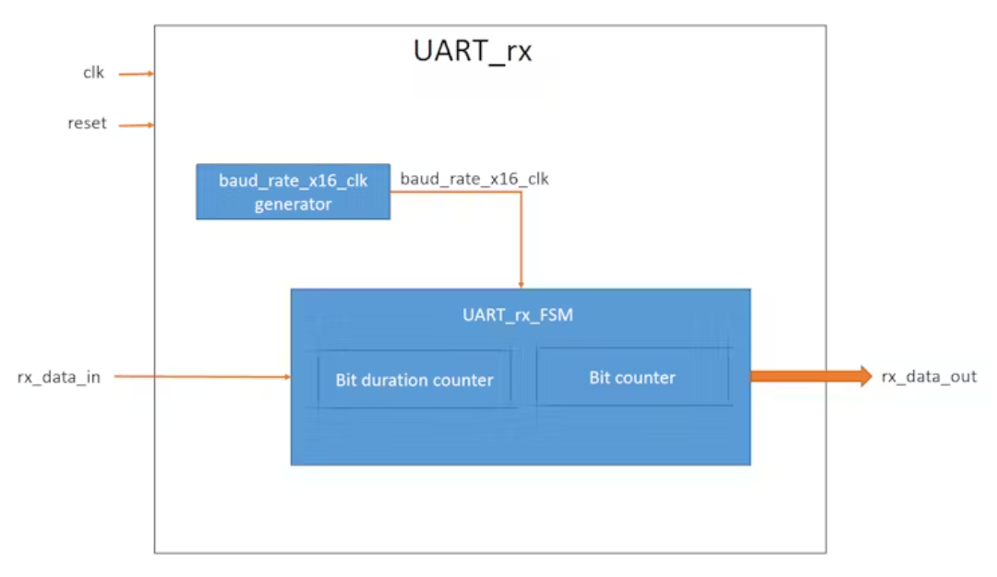

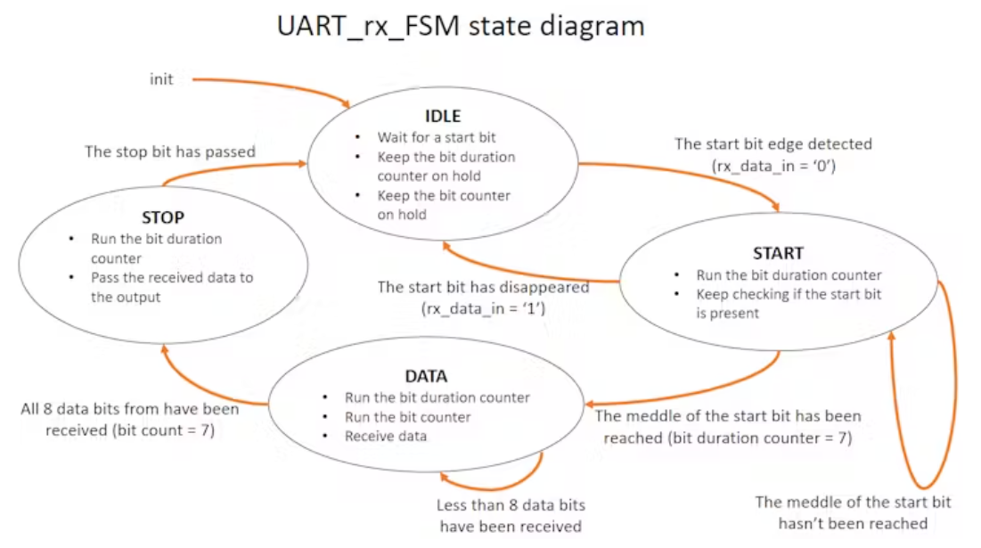

library ieee;

use ieee.std_logic_1164.all; use ieee.numeric_std.all; entity UART_rx is
generic(

BAUD_X16_CLK_TICKS: integer := 54); -- (clk
/ baud_rate) / 16 => (100 000 000 / 115 200)
/ 16 = 54.25

port(

clk : in std_logic; -
- Clock input

reset : in std_logic;
-- Reset input

rx_data_in : in std_logic;
-- Received data input

rx_data_out : out std_logic_vector (7 downto 0) -- Received data output
);

end UART_rx;

architecture Behavioral of UART_rx is

type rx_states_t is (IDLE, START, DATA, STOP);
-- Enumeration for RX states signal rx_state: rx_states_t := IDLE;
-- State signal initialization

signal baud_rate_x16_clk : std_logic := '0';
-- Baud rate x16 clock signal initialization signal rx_stored_data : std_logic_vector(7 downto 0) := (others => '0'); -- Received data storage signal initialization
begin

-- Baud rate x16 clock generator process baud_rate_x16_clk_generator: process(clk)
variable baud_x16_count: integer range 0 to (BAUD_X16_CLK_TICKS - 1) := (BAUD_X16_CLK_TICKS - 1); -- Baud x16
count variable initialization begin
if rising_edge(clk) then if (reset = '1') then
baud_rate_x16_clk <= '0';
-- Reset baud rate x16 clock on reset baud_x16_count :=
(BAUD_X16_CLK_TICKS - 1);

else

if (baud_x16_count = 0) then baud_rate_x16_clk <= '1';
-- Toggle baud rate x16 clock

baud_x16_count := (BAUD_X16_CLK_TICKS - 1); else
baud_rate_x16_clk <= '0';

baud_x16_count := baud_x16_count
- 1;

end if; end if;
end if;

end process baud_rate_x16_clk_generator;

-- UART FSM RX process UART_rx_FSM: process(clk)
variable bit_duration_count : integer range 0 to 15 := 0; -- Bit duration count variable initialization
variable bit_count : integer range 0 to 7 := 0; -- Bit count variable initialization
begin

if rising_edge(clk) then if (reset = '1') then
rx_state <= IDLE;
-- Reset RX state on reset rx_stored_data <= (others => '0');
-- Clear stored data on reet

rx_data_out <= (others => '0');
-- Clear data output on reset bit_duration_count := 0;
-- Reset bit duration count on reset

bit_count := 0;
-- Reset bit count on reset

else

if (baud_rate_x16_clk = '1') then -
- RX FSM works 16 times faster than baud rate
case rx_state is when IDLE =>
rx_stored_data <= (others =>
'0'); -- Clear received data register bit_duration_count := 0;
-- Reset counters

bit_count := 0;

if (rx_data_in = '0') then
-- If start bit received

rx_state <= START;
-- Transition to START state

end if;

when START =>

if (rx_data_in = '0') then
-- Verify start bit presence

if (bit_duration_count = 7) then -- Wait half baud rate cycle
rx_state <= DATA;
-- Transition to DATA state

bit_duration_count := 0; else
bit_duration_count := bit_duration_count + 1;
end if; else
rx_state <= IDLE;
--

False alarm, start bit not present

end if; when DATA =>
if (bit_duration_count = 15) then
-- Wait for one baud rate cycle (approximately)
rx_stored_data(bit_count) <= rx_data_in; -- Store received bit
bit_duration_count := 0; if (bit_count = 7) then
-- If all 8 bits received, transition to STOP
state

rx_state <= STOP; bit_duration_count := 0;
else

bit_count := bit_count + 1; end if;
else

bit_duration_count := bit_duration_count + 1;
end if; when STOP =>
if (bit_duration_count = 15) then
-- Wait for one baud rate cycle

rx_data_out <= rx_stored_data; -- Transfer received data to output
rx_state <= IDLE;
-- Transition to IDLE state

else

bit_duration_count := bit_duration_count + 1;

end if;

when others => rx_state <= IDLE;
-- Default to IDLE state for any other state

end case; end if;
end if; end if;
end process UART_rx_FSM; end Behavioral;
MODULE-3: BUTTON DEBOUNCER

library ieee;

use ieee.std_logic_1164.all; use ieee.numeric_std.all; entity button_debounce is
generic (

COUNTER_SIZE : integer := 10_000 -- Counter size for debounce logic
);

port (

clk : in std_logic; -- Clock input reset : in std_logic; -- Reset input button_in : in std_logic; -- Raw
button input

button_out : out std_logic -- Debounced button output
);

end button_debounce;

architecture Behavioral of button_debounce is

signal flipflop_1 : std_logic := '0'; --
Output of flip-flop 1

signal flipflop_2 : std_logic := '0'; --
Output of flip-flop 2

signal flipflop_3 : std_logic := '0'; --
Output of flip-flop 3

signal flipflop_4 : std_logic := '0'; --
Output of flip-flop 4

signal count_start : std_logic := '0'; --
Signal to trigger counter start begin
-- Input flip-flops process input_flipflops: process(clk) begin
if rising_edge(clk) then if (reset = '1') then
flipflop_1 <= '0'; -- Reset flip- flop 1
flipflop_2 <= '0'; -- Reset flip- flop 2
else

flipflop_1 <= button_in; -- Pass button input to flip-flop 1
flipflop_2 <= flipflop_1; -- Pass flip-flop 1 output to flip-flop 2
end if; end if;
end process input_flipflops;

-- Determine when to start the counter count_start <= flipflop_1 xor flipflop_2; --

Trigger counter start if flip-flops differ

-- Pause counter process

pause_counter: process(clk)

variable count: integer range 0 to COUNTER_SIZE := 0; -- Counter variable begin
if rising_edge(clk) then if (reset = '1') then
count := 0; -- Reset counter on reset flipflop_3 <= '0'; -- Reset flip-flop 3
else

if (count_start = '1') then -- If triggered to start counting
count := 0; -- Reset count elsif (count < COUNTER_SIZE) then -- If
count hasn't reached maximum

count := count + 1; --
Increment count

else

flipflop_3 <= flipflop_2; -- Pass flip-flop 2 output to flip-flop 3
end if; end if;
end if;

end process pause_counter;

-- Output flip-flop process output_flipflop: process(clk) begin
if rising_edge(clk) then

if (reset = '1') then

flipflop_4 <= '0'; -- Reset flip- flop 4
else

flipflop_4 <= flipflop_3; -- Pass flip-flop 3 output to flip-flop 4
end if; end if;
end process output_flipflop;

-- Debounced button output logic with flipflop_3 select
button_out <= flipflop_3 xor flipflop_4 when '1', -- Generate short impulse if button is pressed
'0' when others; -- Otherwise, keep output low;
end Behavioral;

BUTTON CONTROLLER:

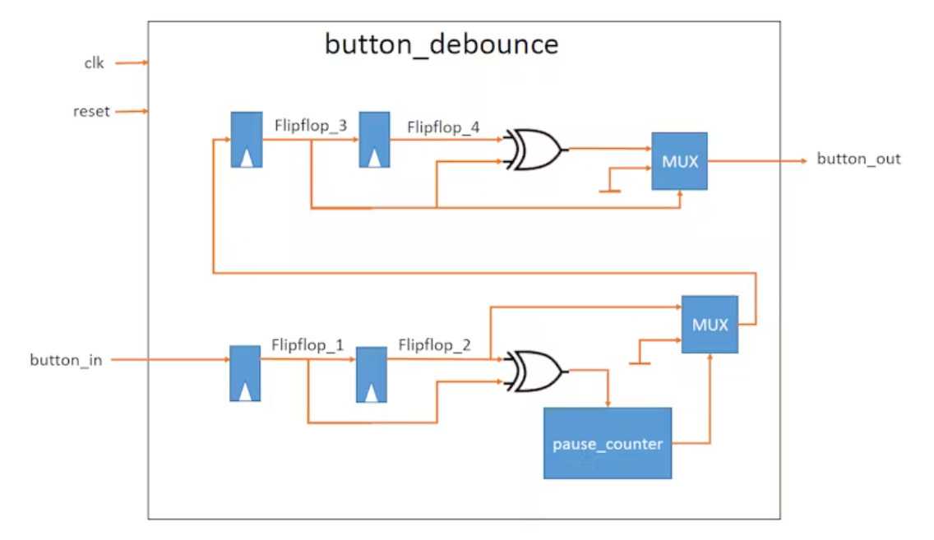

library ieee;

use ieee.std_logic_1164.all; use ieee.numeric_std.all; entity UART_controller is
port(
clk  input | : in std_logic; | -- Clock
reset  input | : in std_logic; | -- Reset
tx_enable | : in std_logic; | --
Enable signal for transmitting data

data_in : in std_logic_vector (7 downto 0);
-- Data input for transmission

data_out : out std_logic_vector (7 downto 0); -- Data output received from UART
rx : in std_logic; -- RX input from UART
tx : out std_logic -- TX output to UART
);

end UART_controller;

architecture Behavioral of UART_controller is component button_debounce
port(

clk : in std_logic; -- Clock input
reset : in std_logic; -- Reset input
button_in : in std_logic; -- Raw button input
button_out : out std_logic -- Debounced button output
);

end component; component UART

port(

clk : in std_logic; -- Clock input reset : in std_logic; -- Reset
input

tx_start : in std_logic; -- Start signal for UART transmission
data_in : in std_logic_vector (7 downto 0); -- Data input to UART
data_out : out std_logic_vector (7 downto 0); -- Data output from UART
rx : in std_logic; -- RX input to UART
tx : out std_logic -- TX output from UART
);

end component;

signal button_pressed : std_logic; --
Debounced button signal begin
-- Button debounce component instantiation tx_button_controller: button_debounce port map(
clk => clk,

reset => reset,

button_in => tx_enable, --Input signal from tx_enable

button_out => button_pressed Debounced button signal
);

-- UART transceiver component instantiation UART_transceiver: UART

port map(

clk => clk,

reset => reset,

tx_start => button_pressed, -- Start signal for UART transmission
data_in => data_in, -- Input data for transmission
data_out => data_out -- Received data output from UART
rx => rx, -- RX input from UART tx => tx -- TX output to UART
);

end Behavioral;

MODULE-4: TESTBENCH CODE

library ieee;

use ieee.std_logic_1164.all; use ieee.numeric_std.all entity UART_controller_tb is
-- Port ( );

end UART_controller_tb;

architecture Behavioral of UART_controller_tb is component UART_controller
port(
clk  input | : in std_logic; | -- Clock
reset | : in std_logic; | -- Reset
input

tx_enable : in std_logic; -- Enable signal for transmitting data

data_in : in std_logic_vector (7 downto 0); -- Data input for transmission
data_out : out std_logic_vector (7 downto 0); -- Data output received from UART
rx : in std_logic; -- RX input from UART
tx : out std_logic -- TX output to UART
);

end component;

signal clk : std_logic := '0'; -- Clock signal
signal reset : std_logic := '0'; --
Reset signal

signal tx_start : std_logic := '0'; --
Transmission start signal

signal tx_data_in : std_logic_vector (7 downto 0) := (others => '0'); -- Data to be transmitted
signal rx_data_out : std_logic_vector (7 downto 0) := (others => '0'); -- Received data from UART
signal tx_serial_out : std_logic := '1'; --
Serial output for transmission

signal rx_serial_in : std_logic := '1'; --
Serial input from UART

constant clock_cycle : time := 10 ns; -- Clock cycle time (1/clk, assuming 100 MHz clock)

begin

-- Instantiate UART controller uut: UART_controller
port map(

clk => clk, reset => reset,
tx_enable => tx_start, data_in => tx_data_in, data_out => rx_data_out, tx => tx_serial_out,
rx => rx_serial_in

);

-- Connect serial output of UART to serial input (loopback)
rx_serial_in <= tx_serial_out;

-- Clock generator process clk_generator: process begin
wait for clock_cycle/2; -- Wait for half clock cycle
clk <= '1'; -- Set clock high

wait for clock_cycle/2; -- Wait for half clock cycle
clk <= '0'; -- Set clock low end process clk_generator;
-- Signal generator process signals_generator: process begin
tx_data_in <= X"55"; -- Initialize data to be transmitted

tx_start <= '0'; -- Ensure transmission start signal is low
wait for 25 us; -- Wait for a specific duration
tx_start <= '1'; -- Set transmission start signal high
wait for 110 us; -- Wait for a specific duration (testing button debounce)
tx_start <= '0'; -- Reset transmission start signal
wait for 205 us; -- Wait for a specific duration
tx_data_in <= X"FF"; -- Change data to be transmitted
wait for 28 us; -- Wait for a specific duration
tx_start <= '1'; -- Set transmission start signal high
wait for 110 us; -- Wait for a specific duration
tx_start <= '0'; -- Reset transmission start signal
wait for 200 us; -- Wait for a specific duration
end process signals_generator; end Behavioral;

HARDWARE TO BE USED:

BASYS-3 FPGABOARD

USB TO UART CONVERTER

